Step 1: Verify Git Installation

Step 2: Configure Git

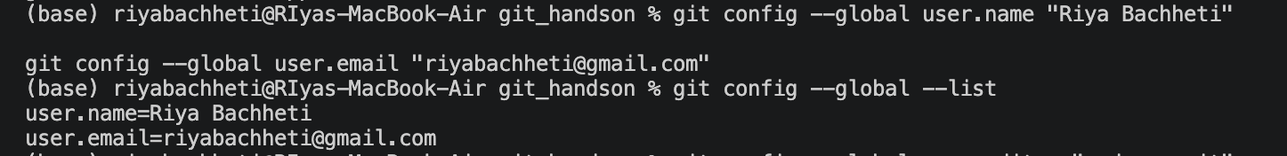

Step 3: Default Editor
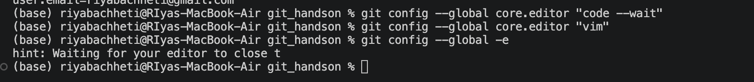

Step 4: Create Local Repository
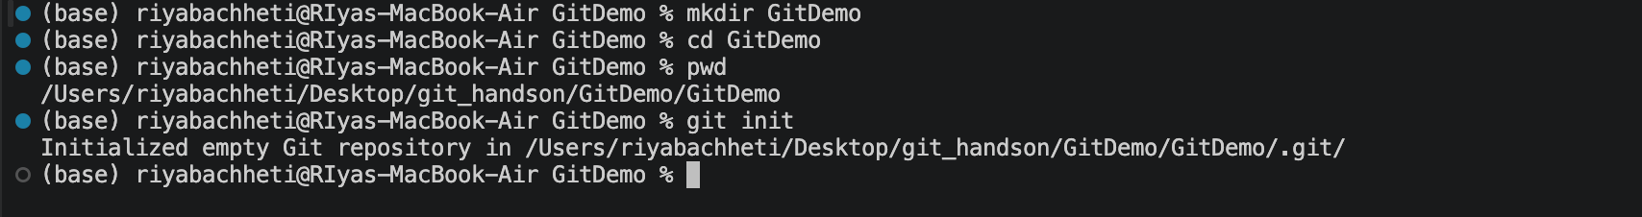
Step 5: Check Hidden Files
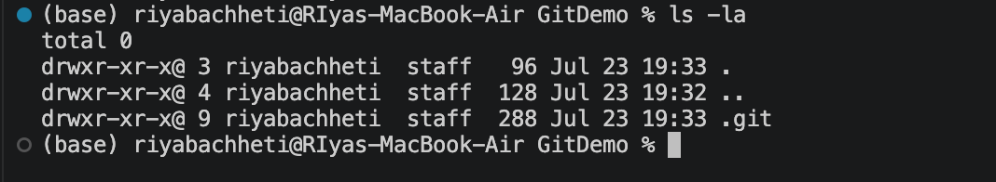
Step 6: Create welcome.txt
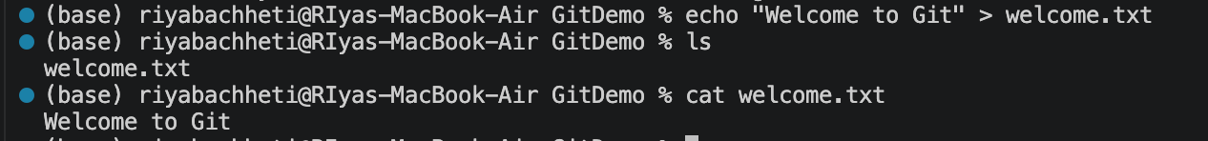
Step 7: Check Status
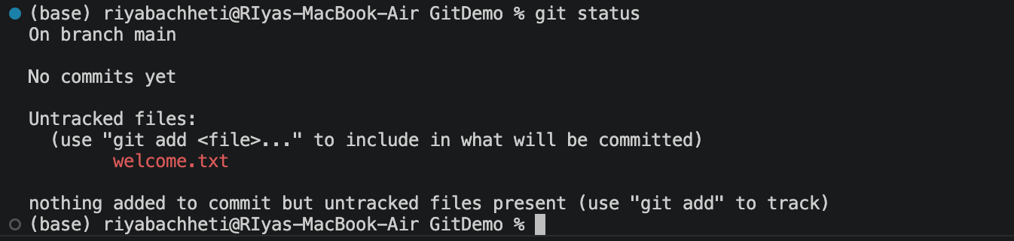
Step 8: Add File
Step 9: Commit
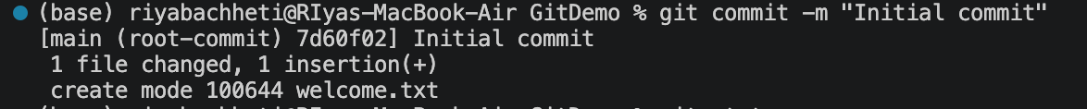
Step 10: Check Status
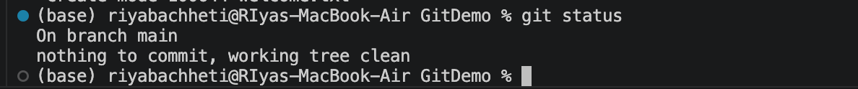
Step 11: Create Remote Repository
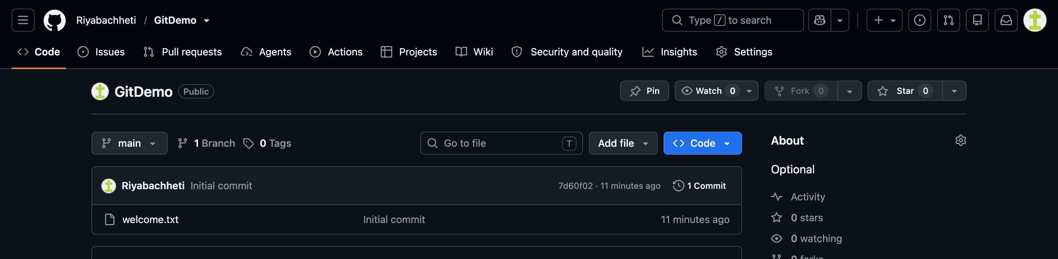

Step 12: Connect Remote
